

**Placement Empowerment Program**

***Cloud Computing and DevOps Centre***

**Set Up a Virtual Machine in the Cloud**Create A free-tier AWS, Azure, or GCP account. Launch a virtual machine and SSH into it.

Name: Harivignesh

Departement: Ads



**Introduction**

In today's digital landscape, cloud computing has revolutionized the way we manage and deploy IT resources. Virtual machines (VMs) allow users to run multiple operating systems on a single physical server, providing flexibility, scalability, and efficiency. This guide will walk you through the process of setting up a virtual machine in the cloud using a free-tier account from AWS, Azure, or Google Cloud Platform (GCP).

**Objective**

The objective of this tutorial is to enable you to:

1. Create a free-tier account on a cloud provider (AWS, Azure, or GCP).
2. Launch a virtual machine.
3. Connect to the VM using SSH (Secure Shell) for secure **Steps to Set Up a Virtual Machine in the Cloud**

**Step 1: Create a Free-Tier Cloud Account**

1. **Choose a Cloud Provider**:
   * Decide on AWS, Azure, or GCP based on your preference or project requirements.
2. **Sign Up for an Account**:
   * Go to the provider's website.
   * Click on “Sign Up” or “Create Account.” o Provide necessary information (email, password, etc.).
   * Verify your identity using a credit card (most providers won’t charge you if you stay within the free tier limits).

**Step 2: Launch a Virtual Machine**

1. **Navigate to the VM Section**:
   * AWS: Go to the EC2 Dashboard. o Azure: Access the Virtual Machines section.
   * GCP: Go to the Compute Engine section.
2. **Create a New VM Instance**:
   * Click on “Launch Instance” or “Create VM.” o Choose a free-tier eligible image (e.g., Ubuntu, Amazon Linux).
   * Select an instance type that falls within the free tier (e.g., t2.micro for AWS, B1S for Azure, e2-micro for GCP). o Configure the instance settings (networking, security, etc.).

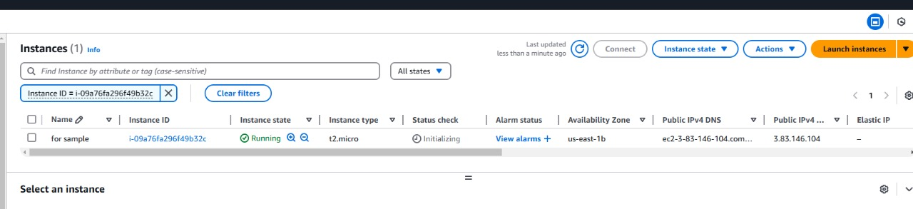

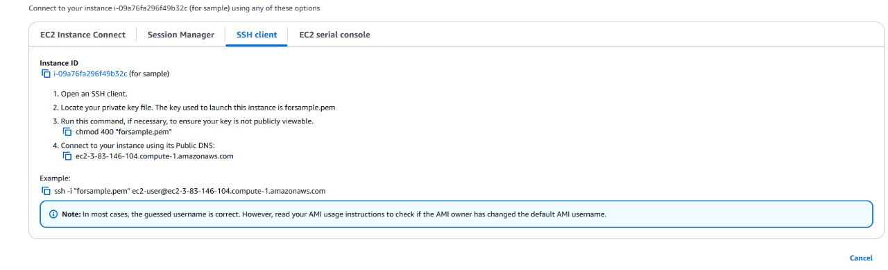

1. **Set Up Firewall Rules**:
   * Ensure that SSH (port 22) is allowed in the firewall settings for remote access.
2. **Launch the VM**:
   * Review your settings and click “Launch” or

“Create.”

**Step 3: SSH into the Virtual Machine**

1. **Obtain the VM's Public IP Address**:
   * After the VM is launched, locate its public IP address in the dashboard.
2. **Open Your Terminal**:
   * On macOS or Linux, open the terminal. o On Windows, use Command Prompt or PowerShell, or an SSH client like PuTTY.
3. **Connect via SSH**:
   * Use the following command to connect:
   * ssh -i /path/to/your/private/key username@publicip-address
   * Replace /path/to/your/private/key with the path to your SSH key, username with the default user (e.g., ec2-user for AWS, azureuser for Azure, ubuntu for GCP), and public-ip-address with the VM’s IP.

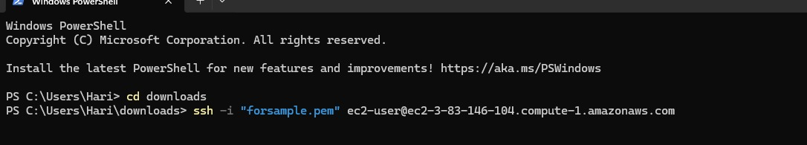

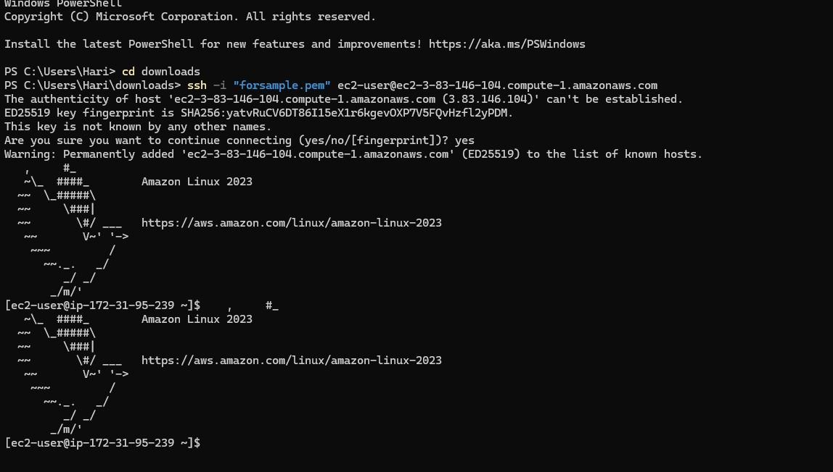

1. **Verify the Connection**:
   * If successful, you’ll have terminal access to your

VM.

**Outcome:**

You have successfully set up a virtual machine in the cloud and connected to it via SSH. With this foundation, you can explore further configurations, install software, and utilize cloud resources for various applications. Happy cloud computing!